**Sri Lanka Institute of Information Technology**

**User Experience Engineering – IT3050**

B.Sc. (Hons) in Information Technology

Group: SER026_WEEKEND

Sustainable Development Goal: Life Below Water

|  |  |
| --- | --- |
| **Student ID** | **Student Name** |
| IT20281564 | M.T Sanju |
| IT20039004 | H.C Liyanage |
| IT20047542 | W.M.K.K.B Walisundara |
| IT20206550 | K.I.K.R.D.N. Kandakkulama |

1. **Sketches**

**IT20281564 - M.T Sanju**

**IT20039004 – Liyanage H.C**

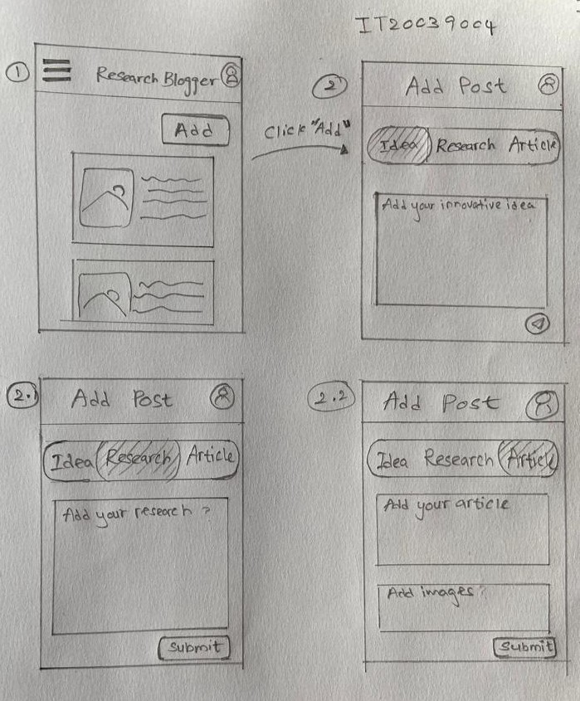

**IT20047542 – W.M.K.K.B Walisundara**

**IT20206550 – K.I.K.R.D.N. Kandakkulama**

1. **Wireframes**

**IT20281564 - M.T Sanju**

**IT20039004 – Liyanage H.C**

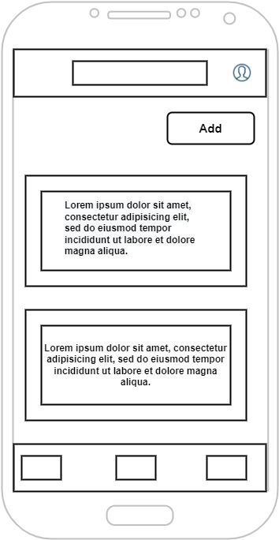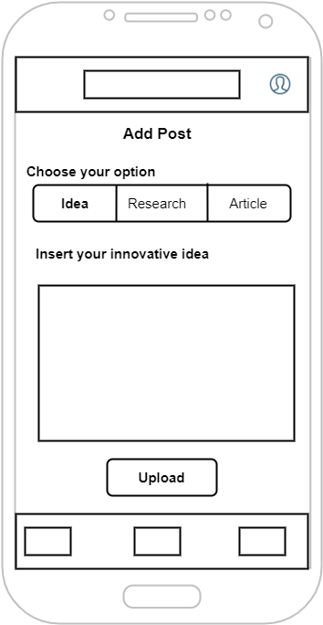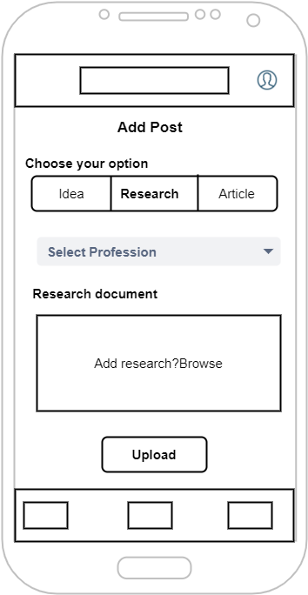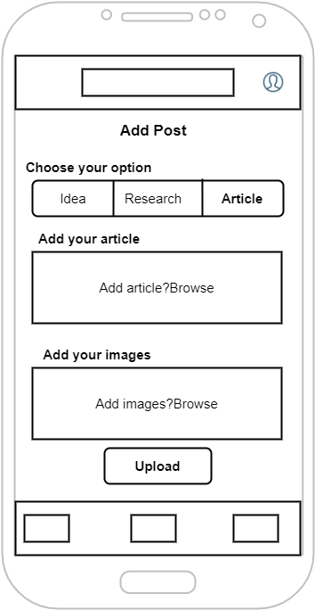

**IT20047542 – W.M.K.K.B Walisundara**

**IT20206550 – K.I.K.R.D.N. Kandakkulama**

1. **UI’s**

**IT20281564 - M.T Sanju**

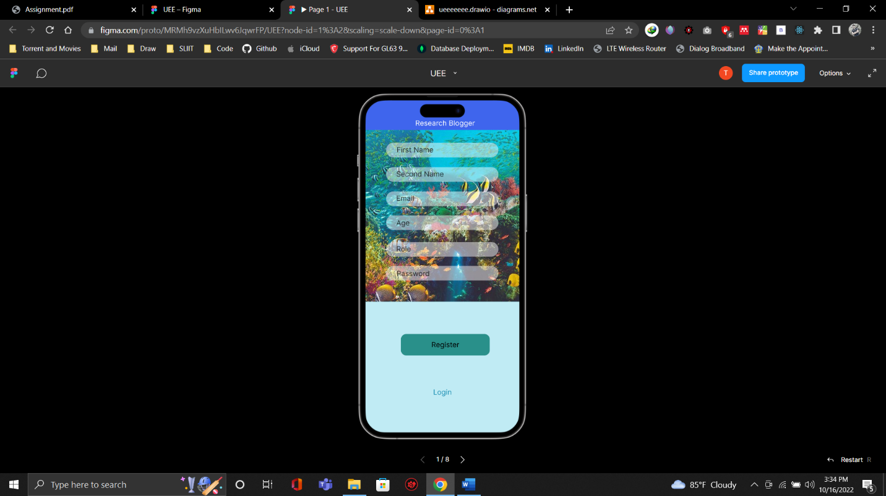

Signup Login User Home

Update Profile Popup on Update Popup on Delete

**IT20039004 – Liyanage H.C**

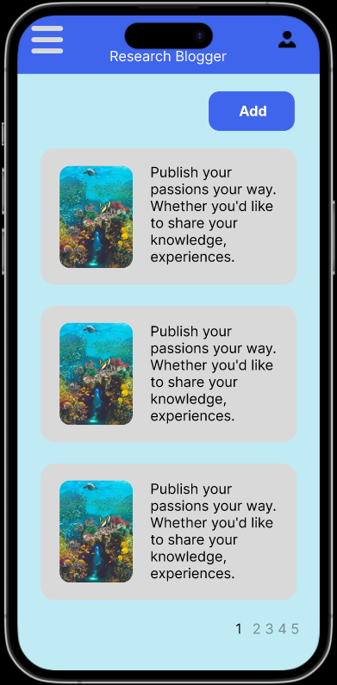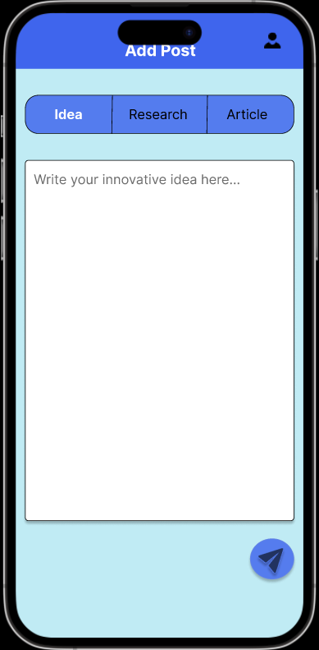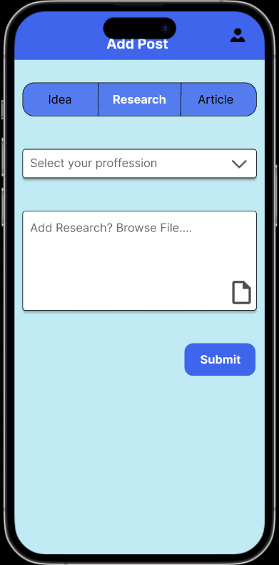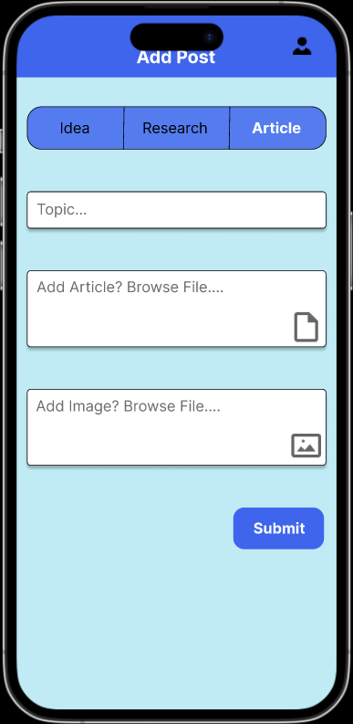

**IT20047542 – W.M.K.K.B Walisundara**

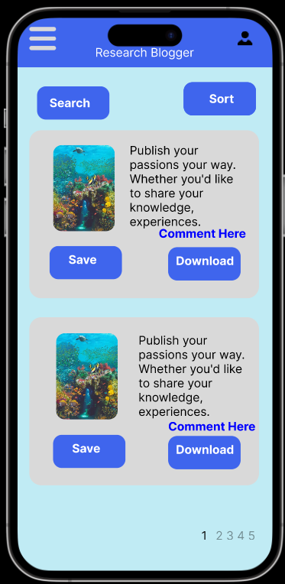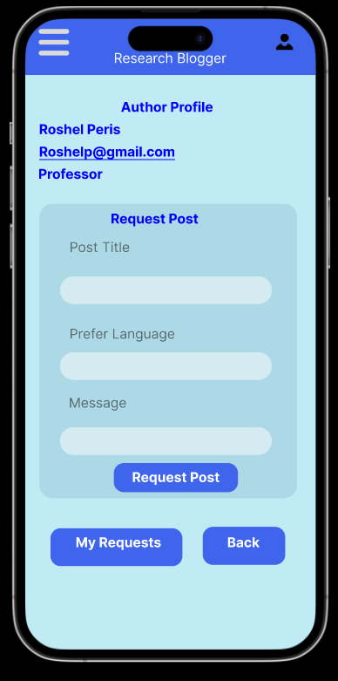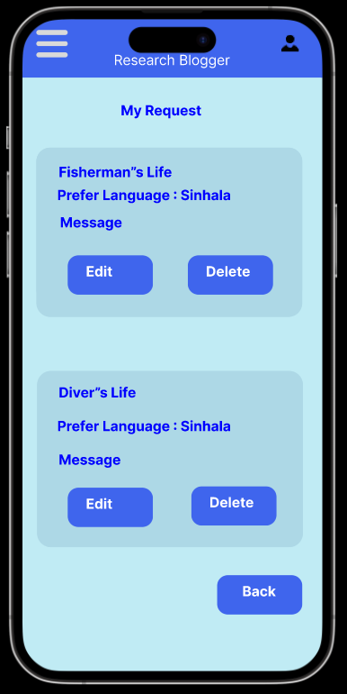

**Blog Home UI**

**Mark as read UI**

**Author Profile UI UI**

**Request Research paper UI**

IT20206550 – Kandakkulama K.I.K.R.D.N

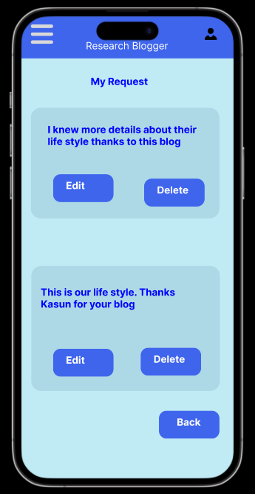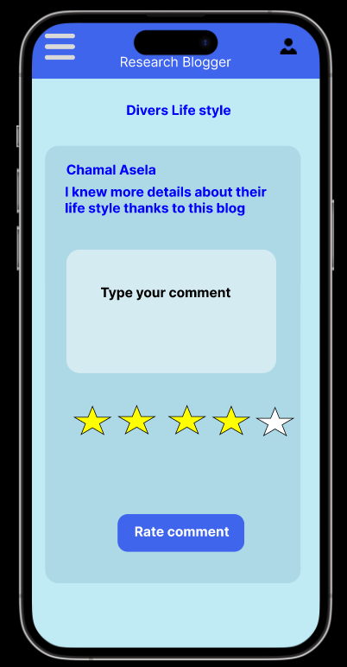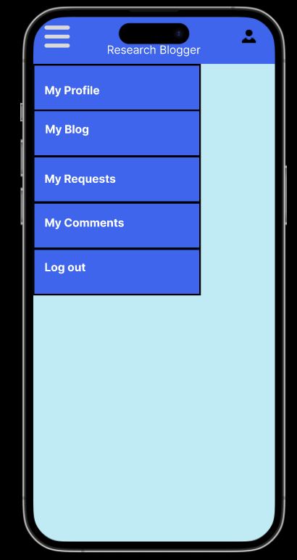

**Add Comment UI**

**Reply comment UI**

**Side Menu UI**

**My comments UI**

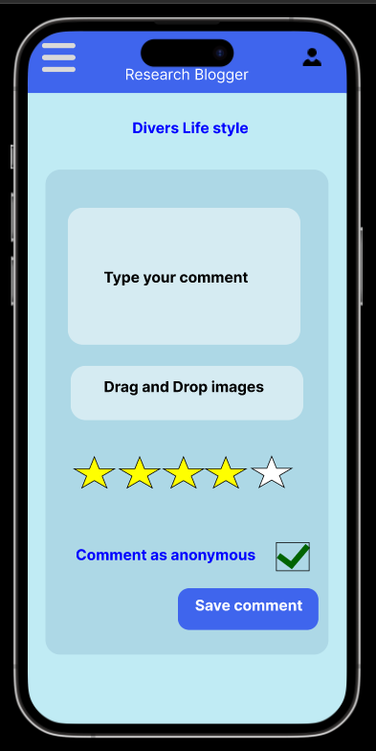

**Comments View UI**

1. **Prototype**

1. **User Review**

Link - <https://forms.gle/r5zLrzBHENYGXRGY6>

